Close

Cumulative Quiz

10 questions

1.

Interviewing both technophile and techophobe users provides useful insights for design.



False



True

Correct Response

Correct! This is a question on extreme users. We can learn from both sides of the spectrum. If designing an email service, for example, it would be important to interview people who handle hundreds of emails daily and those who check email a few times a month.

2.

Storyboarding allows designers:



to showcase the user interface



to focus on the task the user is performing.

Correct Response

Correct! The storyboard is an exercise that helps communicate what task and need we are trying to design for. Sequence, setting, satisfaction rather than details and specifics of user interface.



to discuss details on the final product and marketing plan for that product



to create an immersive, detailed world that will feel realistic to all users

3.

Let's say your friend is trying to understand how a software company decides when software is released, and she interviews one of their engineers. She asks, "At several companies, the CEO is completely in charge of the decision of when to release the software. How do you do it at your company?"

What is true of your friend's interview question? Check all that apply



This is a great question. It provides the user context about the kind of answer that is expected.

Correct Response

By setting the norm (the "several companies" part), it suggests/leads to a favored answer. Having a more open-ended question invites more interesting answers.



This is a leading question: it suggests that the CEO should make the decision

Correct Response

Even though the question is not explicitly leading, by setting the norm (the "several companies" part), it suggests/leads to a favored answer.



This is the wrong question, since it focuses the user on who makes the decision rather than how the decision is reached.

Correct Response

Putting irrelevant information into the question sets the user off on the wrong track (esp. when coupled with the "how do you do it" open-ended question, the user is likely to guess "Ah, by how, they mean who...")



This is a great question, since the interviewer establishes she is an expert in the field.

Correct Response

The interviewer wants to appear as the inexpert apprentice, and learn from the interviewee. Posing as an expert often makes people unwilling to talk les the expert think they are wrong.

4.

You need a complete product to employ the Wizard of Oz technique.



True



False

Correct Response

The Wizard of Oz technique is employed to test the interaction and user experience without going through the trouble of creating a fully functional product.

5.

When prototyping with a team, what are the benefits of sharing multiple designs with your team members, compared to sharing only one design? Check all that apply.



Sharing multiple designs leads to more sharing of features between designs.

Incorrect Response

This is correct! Refer to the slide at 7:50 in the "Creating and Comparing Alternatives" video.



Sharing multiple designs leads to more individual exploration of the space of possible designs.



Sharing multiple designs leads to increased group rapport.



Sharing multiple designs provides a vocabulary for talking with the team about the space of possible designs.

6.

What are advantages of paper prototypes over computer generated pixel prototypes? Check all that apply.



Paper prototypes keep the focus on high-level design while it's easy to shift focus to details with pixel-prototypes

Correct Response

With pixel-prototypes, you reason what can fit well on a screen and start to invite more formal design critiques. Paper prototypes are meant to be quick and highly iterative.



Paper prototypes are often less expensive, faster, and easier to create and modify compare to computer generated prototypes

Correct Response

Paper prototypes can be created with any material you have available, there aren't any rules or limits! By nature, paper prototypes are highly iterative so modifications and ideas can be made and created on the fly.



Paper prototypes separate issues of design from issues of implementation.

Correct Response

The focus with paper prototypes is on high-level design. Paper prototypes are meant to act as "icebreakers" to help get creative juices flowing and start conversation about design ideas.



Paper prototypes usually allow designers to explore a broader range of ideas than pixel-prototypes.

Correct Response

The goal of paper prototypes is to get feedback from other stakeholders and spark conversation about design ideas. Having multiple prototypes will get you better feedback and better value out of testing multiple designs.

7.

Imagine you’re designing the world’s first voice-guided navigation system for a car GPS. At this stage in the design process, you want to find out if drivers can understand and respond to your voice directions while driving a car. Which prototype would you build for this purpose?



A paper prototype of the GPS display with multiple “screens” that each shows the map at a different part of a route. The participant evaluates the prototype in a lab. For each screen, the experimenter speaks out the turn directions, and asks the participant what she would do (e.g. “I’d take the next exit”).



Create a video of a person driving on a route, and then add your instructions as voiceover. Show participants this video, and pause the video after each instruction, and ask what participants would do.



Create a fully functional system (with a database of routes, directions and voice-clips etc.) on a laptop, and put the laptop in the car. The participant drives the car along the route, and hears the turn directions from the laptop.



Have pre-determined turn-by-turn directions for a particular route written on a notepad. The experimenter reads out the right directions while the participant drives on the route.

Correct Response

This prototype recreates the most important conditions (remember we’re trying to test “if drivers can understand and respond to your voice directions while driving”), with the lowest cost. In that sense it is the best of the 4 options.

8.

You are a researcher interested in finding out what times of day people are the sleepiest. Which technique would allow you to collect the most data from the greatest number of people with the greatest accuracy?



Interview



Participant observation

Incorrect Response

This limits the number of people who can collect information from, as you would have to observe the whole day if you wanted as much data as possible about when the person is sleepiest. In addition, you may not be able to tell from observation how sleepy the person is.



Survey

Incorrect Response

People may not be able to accurately recall the times in which they are sleepiest in retrospect.



Experience sampling/pager studies

9.

What is wrong with the following interview question: “Do you like the Word Art feature of Microsoft Office?” Check all that apply.



The question assumes that the user has feelings about the Word Art feature of Microsoft Office

Correct Response

Even assuming that a user likes or dislikes a feature can be leading.



The question elicits a binary or yes/no response.

Correct Response

Interview questions should require the user to give more in-depth feedback.



The question is leading.

Incorrect Response

Even assuming that a user likes or dislikes a feature can be leading.



The question is too open ended.

Correct Response

This question is not open ended. Additionally, open-ended questions provide more interesting responses.

10.

What heuristic is clearly violated by both these interfaces?

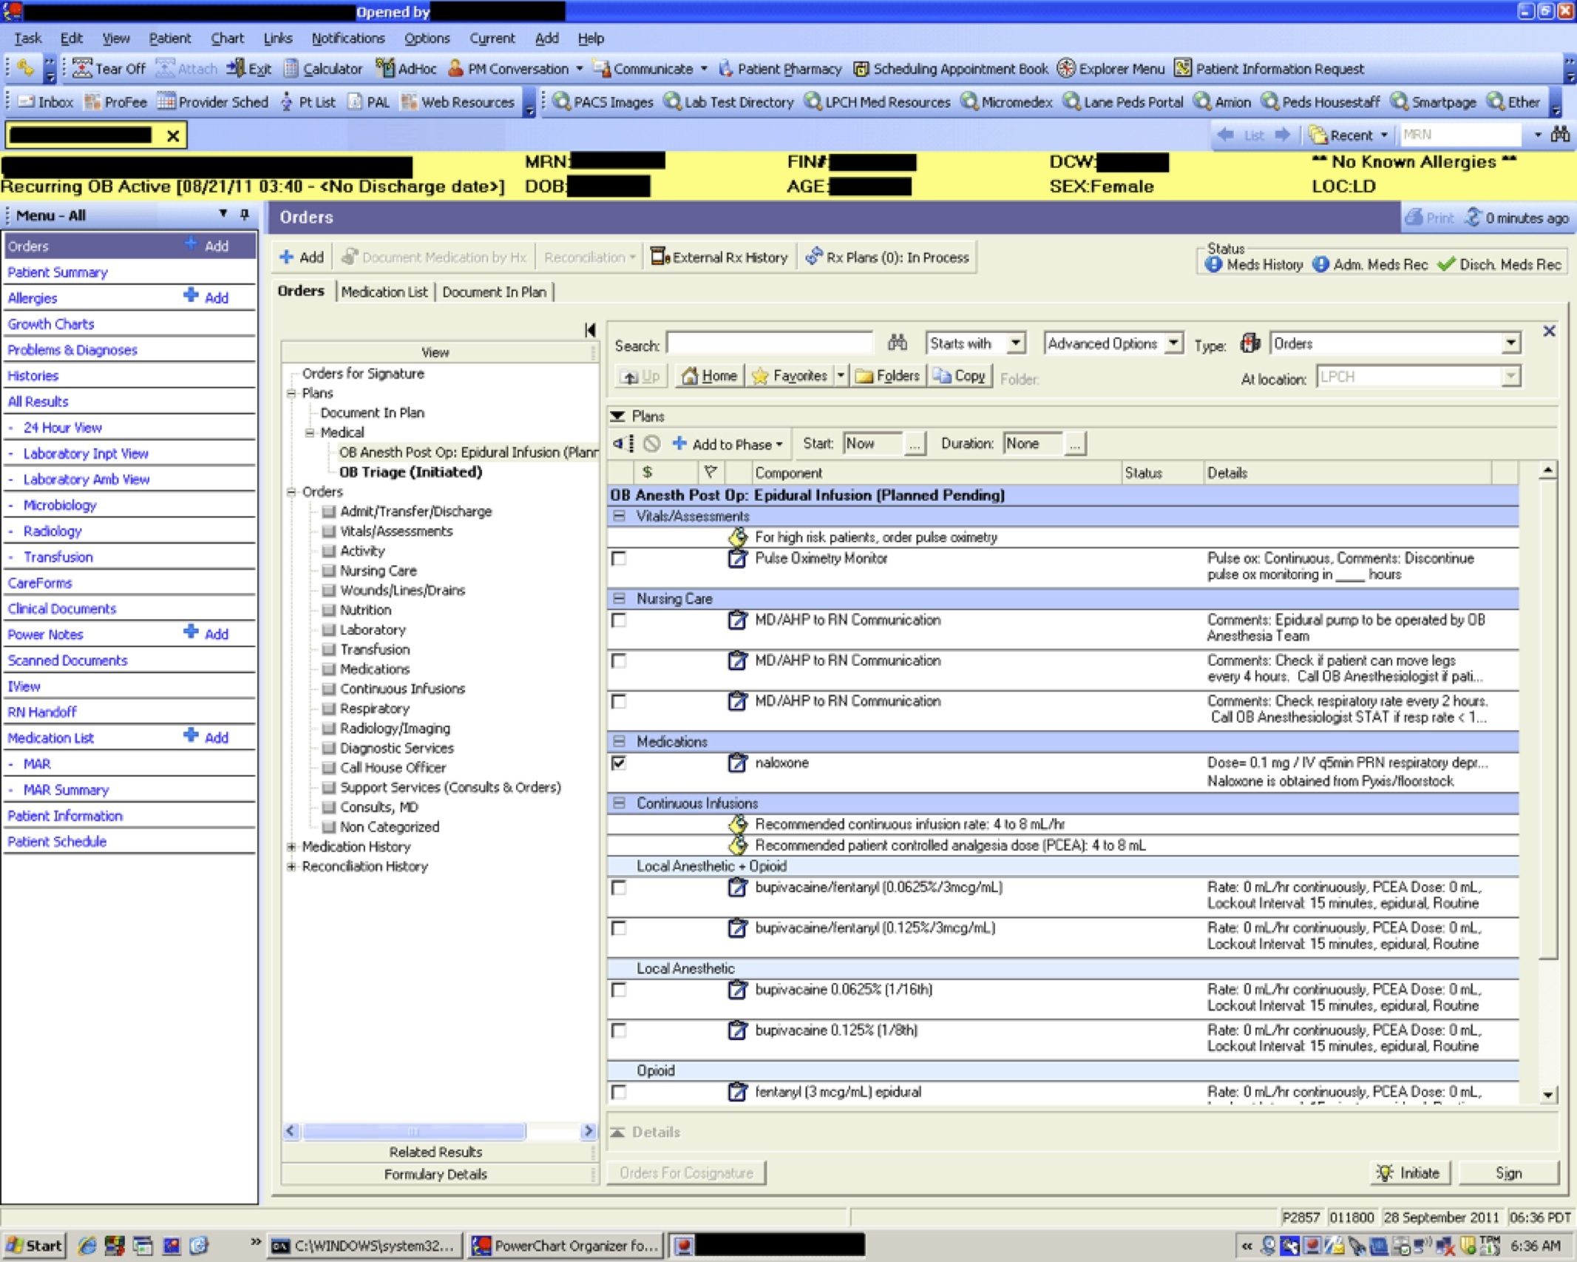

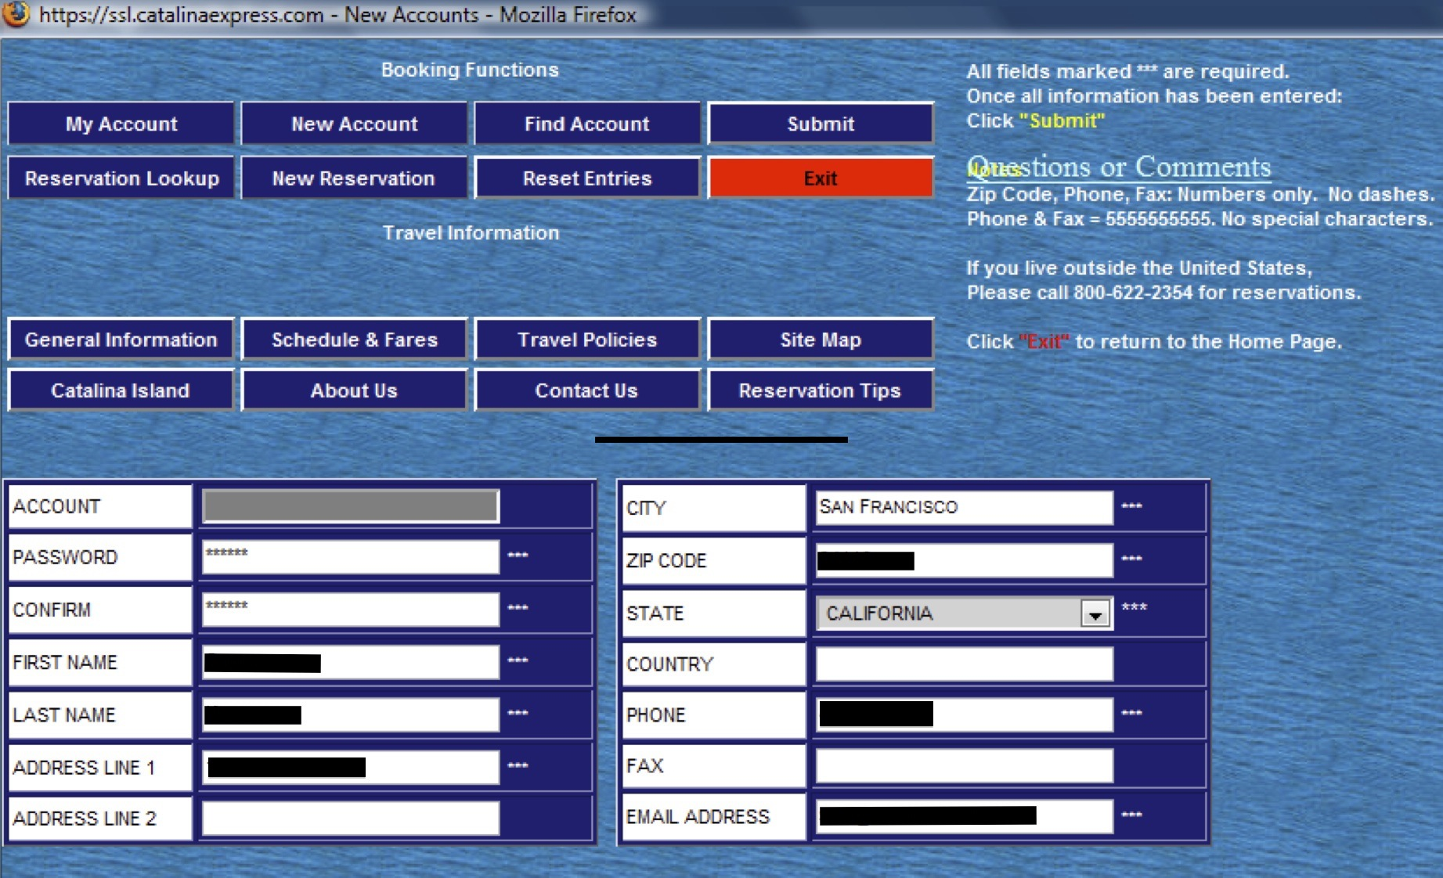



Flexibility and efficiency



None



Aesthetics and minimalist design

Correct Response

Both interfaces are cluttered and have a lot of noise, which makes it hard for users to find and focus on the information they care the most about.



Recognize, diagnose & recover from errors



Recognition over recall



Help

6 questions unanswered

Submit Quiz